Project Planning Phase
Project Planning Template (Product Backlog, Sprint Planning, Stories, Story points)

Date | 30 September 2026
Team ID | SWTID-2026-3555
Project Name | AI Study Buddy
Maximum Marks | 5 Marks

Product Backlog, Sprint Schedule, and Estimation (4 Marks)
Use the below template to create product backlog and sprint schedule
Sprint | Functional Requirement (Epic) | User Story Number | User Story / Task | Story Points | Priority | Team Members
Sprint-1 | Registration | USN-1 | As a user, I can register for the application by entering my email, password, and confirming my password. | 3 | High | Member 1
Sprint-1 |  | USN-2 | As a user, I will receive a confirmation email once I have registered for the application. | 2 | High | Member 1
Sprint-1 |  | USN-3 | As a user, I can register for the application through Gmail. | 2 | Medium | Member 1
Sprint-1 | Login | USN-4 | As a user, I can log into the application by entering email & password. | 2 | High | Member 2
Sprint-1 | Dashboard | USN-5 | As a user, I can see a dashboard with quick links to chat, notes, quizzes and planner. | 3 | High | Member 3
Sprint-1 | Profile | USN-6 | As a user, I can set my grade/course, subjects and study goals in my profile. | 3 | Medium | Member 3
Sprint-1 | AI Doubt Solver | USN-7 | As a user, I can type a question and receive a clear step-by-step answer from the AI tutor. | 5 | High | Member 2
Sprint-2 | AI Doubt Solver | USN-8 | As a user, I can ask follow-up questions and the AI remembers the conversation context. | 3 | High | Member 2
Sprint-2 | Notes Summariser | USN-9 | As a user, I can upload my notes (PDF/DOCX/text) to the application. | 5 | High | Member 4
Sprint-2 | Notes Summariser | USN-10 | As a user, I can get a short summary and key points of my uploaded notes. | 5 | High | Member 2
Sprint-2 | AI Doubt Solver | USN-11 | As a user, I can choose the explanation level (simple / normal / advanced). | 3 | Medium | Member 3
Sprint-2 | Notes Summariser | USN-12 | As a user, I can save summaries and view them later. | 2 | Medium | Member 4
Sprint-2 | Login | USN-13 | As a user, I can reset my password through an email link. | 2 | Medium | Member 1
Sprint-3 | Quiz | USN-14 | As a user, I can generate a multiple-choice quiz from a topic or my notes. | 5 | High | Member 2
Sprint-3 | Quiz | USN-15 | As a user, I can see my score and explanations for right and wrong answers. | 3 | High | Member 3
Sprint-3 | Flashcards | USN-16 | As a user, I can generate flashcards from my notes. | 5 | Medium | Member 2
Sprint-3 | Flashcards | USN-17 | As a user, I am reminded to review flashcards using spaced repetition. | 4 | Medium | Member 4
Sprint-3 | Dashboard | USN-18 | As a user, I can bookmark useful answers and summaries. | 3 | Low | Member 3
Sprint-4 | Study Planner | USN-19 | As a user, I can create a personalised study plan based on my exam date and subjects. | 5 | High | Member 2
Sprint-4 | Study Planner | USN-20 | As a user, I receive email/in-app reminders for my study tasks. | 3 | Medium | Member 1
Sprint-4 | Progress Tracking | USN-21 | As a user, I can view my progress and weak topics on a dashboard. | 5 | High | Member 3
Sprint-4 | Administration | USN-22 | As an administrator, I can manage users and monitor usage of the application. | 4 | Medium | Member 4
Sprint-4 | AI Doubt Solver | USN-23 | As a user, I can rate AI answers so the quality can be improved. | 3 | Low | Member 4

Project Tracker, Velocity & Burndown Chart: (4 Marks)
Sprint | Total Story Points | Duration | Sprint Start Date | Sprint End Date (Planned) | Story Points Completed (as on Planned End Date) | Sprint Release Date (Actual)
Sprint-1 | 20 | 6 Days | 05 Oct 2026 | 10 Oct 2026
Sprint-2 | 20 | 6 Days | 12 Oct 2026 | 17 Oct 2026
Sprint-3 | 20 | 6 Days | 19 Oct 2026 | 24 Oct 2026
Sprint-4 | 20 | 6 Days | 26 Oct 2026 | 31 Oct 2026

Velocity:
Sprint duration is 6 days and the planned velocity of the team is 20 story points per sprint (80 story points in 4 sprints). Average velocity (AV) per iteration unit (story points per day) = Sprint velocity / Sprint duration = 20 / 6 ≈ 3.33 story points per day. The total project effort of 80 story points is therefore planned to be completed in 24 working days.


Burndown Chart:
A burn down chart is a graphical representation of work left to do versus time. It is often used in agile software development methodologies such as Scrum. However, burn down charts can be applied to any project containing measurable progress over time.
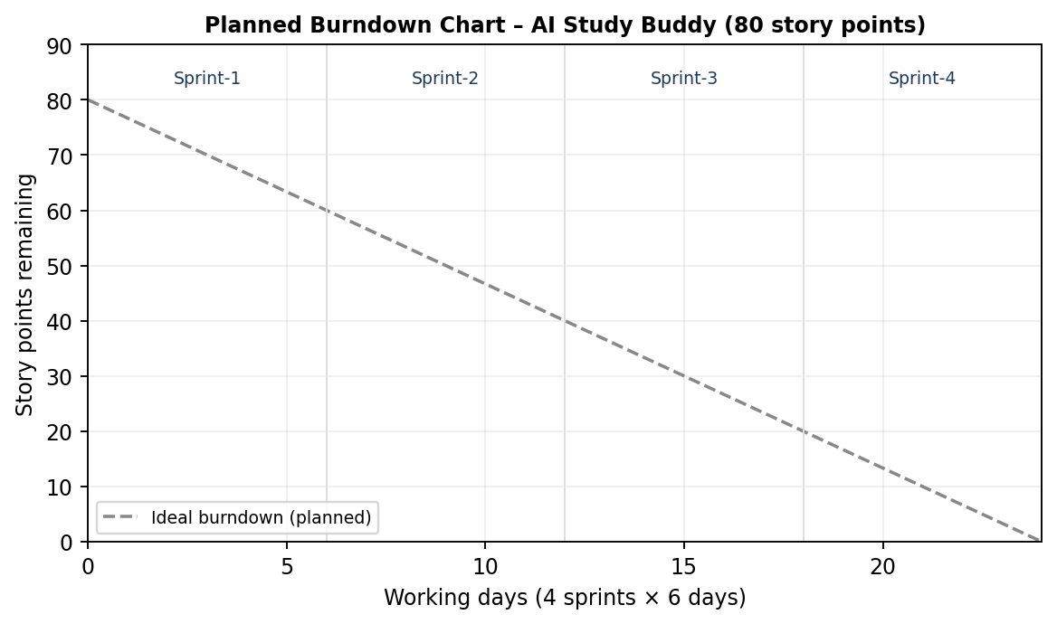
https://www.visual-paradigm.com/scrum/scrum-burndown-chart/
https://www.atlassian.com/agile/tutorials/burndown-charts

Reference:
https://www.atlassian.com/agile/project-management
https://www.atlassian.com/agile/tutorials/how-to-do-scrum-with-jira-software
https://www.atlassian.com/agile/tutorials/epics
https://www.atlassian.com/agile/tutorials/sprints
https://www.atlassian.com/agile/project-management/estimation
https://www.atlassian.com/agile/tutorials/burndown-charts

